Project part 2 exam:

Lab 9: Disk Management: Disk Scheduling Algorithms

Instructions
- MAKE SURE TO USE THE EXAM VERSION OF THE SIMULATOR SimDschedExam7.py
- When explaining the results of each investigation always relate your explanations to how the specific algorithms in the question make their choices about the order of visiting the tracks and YOU MUST use examples from the data. That is, explain why the tracks are visited in the order shown in terms of why the particular algorithm you are dealing with made those decisions using some examples from your data and explaining the algorithm’s movement (e.g. to the disk edges or not, processing request in both directions or not, dividing the requests into groups, forming a queue, etc.)
- EDIT THIS document to insert your answers. Make sure to save it frequently.
- Time: 45 minutes - Submit your completed document by the end of the hour on the submission link provided. Please DO NOT submit a PDF.
- Copy and paste images of all of the relevant data in question throughout your document to illustrate your answers.
- If necessary, re-run the program but make sure to show the new data in your answer.
- Where relevant choose 0 to nnn (upwards) scanning direction.

For each question you will need to add in 5 new requests once the first 2 requests have been completed. See the example run on the last page here which shows this being done. Note the aspects highlighted in blue – these are examples of the critical parts.

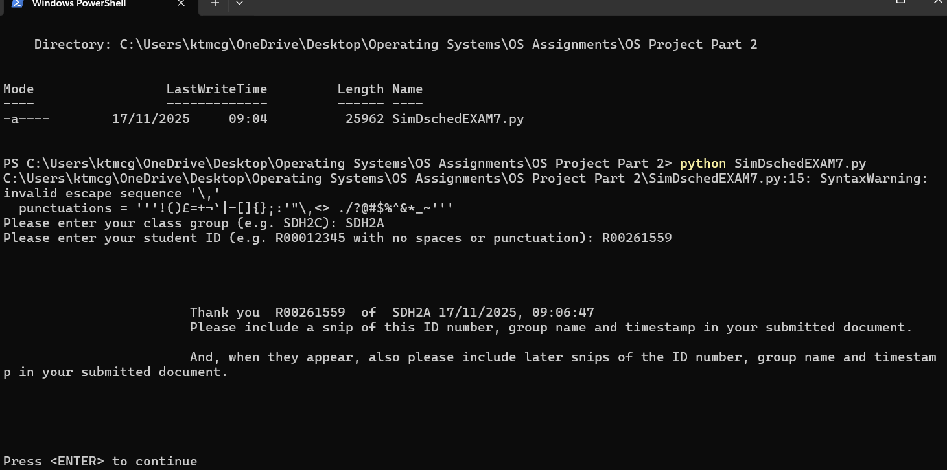

Questions
- (70 marks)
For each of the three algorithms listed below run a simulation of it and
  - Add in 5 new requests once the first 2 requests have been done. Add requests that are near the current track. The purpose of the new requests is to demonstrate the fairness/unfairness of the algorithm so think carefully when choosing the new requested track numbers.
(15 marks)

  - Use the snipping tool to copy and paste all of the data used and the output generated into your document. (15 marks)

Shortest Seek Time First (SSTF)

************** Shortest Seek Time First **************

Will you want to add data while tracks are being processed (y/[n])? y
Have done [269]
New data for SSTF (y/[n])? n
Have done [269, 121]
New data for SSTF (y/[n])? y
How many new Disk Track Requests (Max 10)? 5
Disk Track Requested (integer 0-799)? 582
Disk Track Requested (integer 0-799)? 491
Disk Track Requested (integer 0-799)? 567
Disk Track Requested (integer 0-799)? 599
Disk Track Requested (integer 0-799)? 347
Have done [269, 121, 54]
New data for SSTF (y/[n])? n
Have done [269, 121, 54, 347]
New data for SSTF (y/[n])? n
Have done [269, 121, 54, 347, 491]
New data for SSTF (y/[n])? n
Have done [269, 121, 54, 347, 491, 547]
New data for SSTF (y/[n])? n
Have done [269, 121, 54, 347, 491, 547, 548]
New data for SSTF (y/[n])? n
Have done [269, 121, 54, 347, 491, 547, 548, 549]
New data for SSTF (y/[n])? n
Have done [269, 121, 54, 347, 491, 547, 548, 549, 564]
New data for SSTF (y/[n])? n
Have done [269, 121, 54, 347, 491, 547, 548, 549, 564, 567]
New data for SSTF (y/[n])? n
Have done [269, 121, 54, 347, 491, 547, 548, 549, 564, 567, 582]
New data for SSTF (y/[n])? n
Have done [269, 121, 54, 347, 491, 547, 548, 549, 564, 567, 582, 599]
New data for SSTF (y/[n])? n
Have done [269, 121, 54, 347, 491, 547, 548, 549, 564, 567, 582, 599, 620]
New data for SSTF (y/[n])? n
Have done [269, 121, 54, 347, 491, 547, 548, 549, 564, 567, 582, 599, 620, 627]
New data for SSTF (y/[n])? n
Have done [269, 121, 54, 347, 491, 547, 548, 549, 564, 567, 582, 599, 620, 627, 759]
New data for SSTF (y/[n])? n
In the SSTF algorithm simulation the following track requests were input (in order of arrival): [549, 269, 759, 54, 547, 548, 620, 627, 564, 121, 582, 491, 567, 599, 347]
and at the beginning of the simulation the r/w head was initially at track 280
Track requests were processed by SSTF in the following order: R00261559 SDH2A 17/11/2025, 09:06:47
[269, 121, 54, 347, 491, 547, 548, 549, 564, 567, 582, 599, 620, 627, 759]
Numbers of tracks crossed for each request:
From 280 to 269 : 11
From 269 to 121 : 148
From 121 to 54 : 67
From 54 to 347 : 293
From 347 to 491 : 144
From 491 to 547 : 56
From 547 to 548 : 1
From 548 to 549 : 1
From 549 to 564 : 15
From 564 to 567 : 3
From 567 to 582 : 15
From 582 to 599 : 17
From 599 to 620 : 21
From 620 to 627 : 7
From 627 to 759 : 132

Total number of tracks crossed: 931 R00261559 SDH2A 17/11/2025, 09:06:47

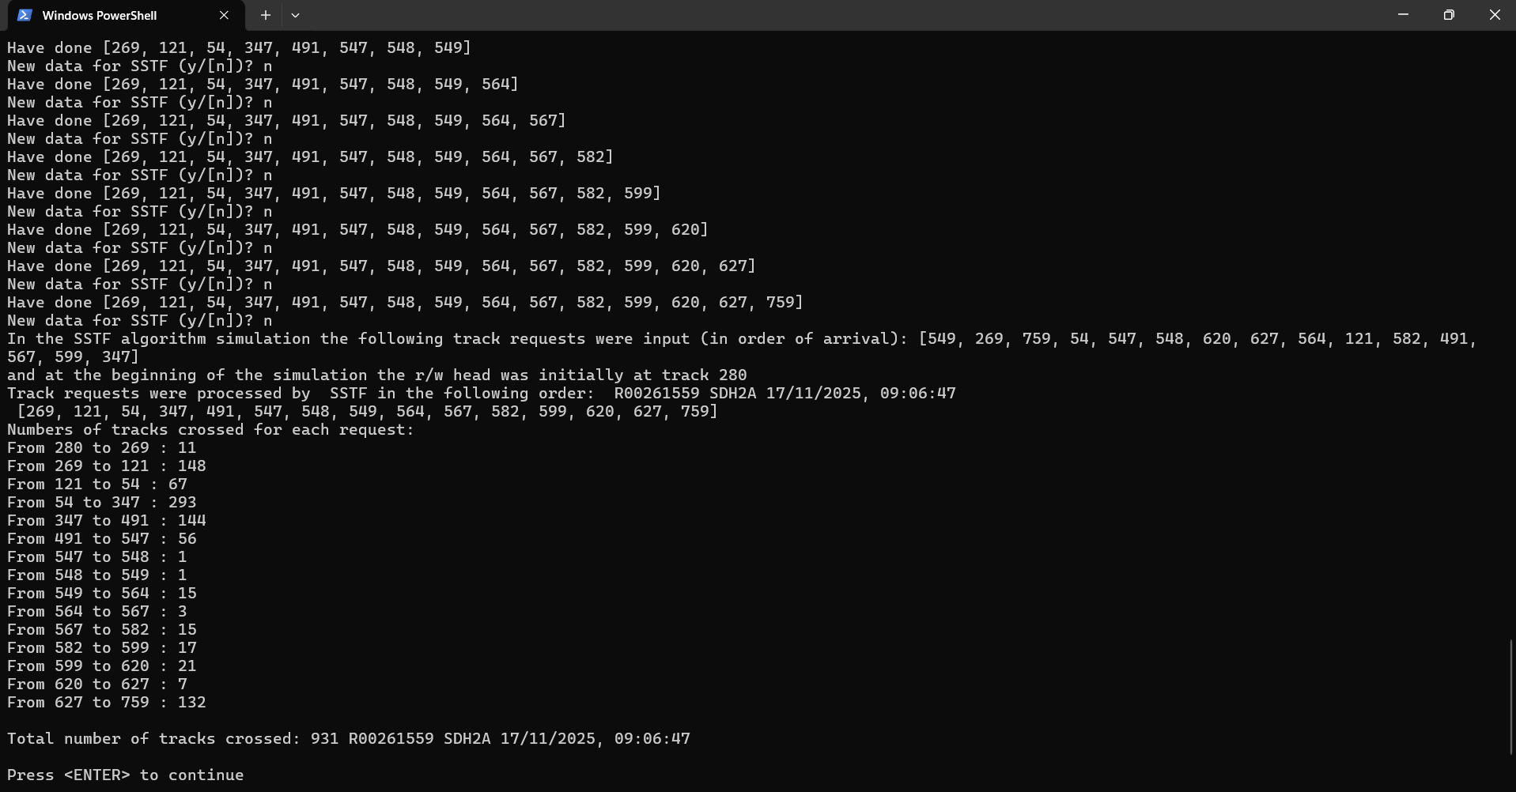
CLook

************** clook Algorithm **************

Choose Scan Direction

1: From 0 to 799
2: From 799 to 0
Which scanning direction (1 or 2)?1
Will you want to add data while tracks are being processed (y/[n])? y
Have done [547]
New data for clook (y/[n])? n
Have done [547, 548]
New data for clook (y/[n])? y
How many new Disk Track Requests (Max 10)? 5
Disk Track Requested (integer 0-799)? 567
Disk Track Requested (integer 0-799)? 589
Disk Track Requested (integer 0-799)? 498
Disk Track Requested (integer 0-799)? 512
Disk Track Requested (integer 0-799)? 654
Have done [547, 548, 549]
New data for clook (y/[n])? n
Have done [547, 548, 549, 564]
New data for clook (y/[n])? n
Have done [547, 548, 549, 564, 567]
New data for clook (y/[n])? n
Have done [547, 548, 549, 564, 567, 589]
New data for clook (y/[n])? n
Have done [547, 548, 549, 564, 567, 589, 620]
New data for clook (y/[n])? n
Have done [547, 548, 549, 564, 567, 589, 620, 627]
New data for clook (y/[n])? n
Have done [547, 548, 549, 564, 567, 589, 620, 627, 654]
New data for clook (y/[n])? n
Have done [547, 548, 549, 564, 567, 589, 620, 627, 654, 759]
New data for clook (y/[n])? n
Have done [547, 548, 549, 564, 567, 589, 620, 627, 654, 759, 54]
New data for clook (y/[n])? n
Have done [547, 548, 549, 564, 567, 589, 620, 627, 654, 759, 54, 121]
New data for clook (y/[n])? n
Have done [547, 548, 549, 564, 567, 589, 620, 627, 654, 759, 54, 121, 269]
New data for clook (y/[n])? n
Have done [547, 548, 549, 564, 567, 589, 620, 627, 654, 759, 54, 121, 269, 498]
New data for clook (y/[n])? n
Have done [547, 548, 549, 564, 567, 589, 620, 627, 654, 759, 54, 121, 269, 498, 512]
New data for clook (y/[n])? n
In the CLook algorithm simulation the following track requests were input (in order of arrival): [549, 269, 759, 54, 547, 548, 620, 627, 564, 121, 567, 589, 498, 512, 654]
and at the beginning of the simulation the r/w head was initially at track 280
Track requests were processed by CLook in the following order: R00261559 SDH2A 17/11/2025, 09:06:47
[547, 548, 549, 564, 567, 589, 620, 627, 654, 759, 54, 121, 269, 498, 512]
Numbers of tracks crossed for each request:
From 280 to 547 : 267
From 547 to 548 : 1
From 548 to 549 : 1
From 549 to 564 : 15
From 564 to 567 : 3
From 567 to 589 : 22
From 589 to 620 : 31
From 620 to 627 : 7
From 627 to 654 : 27
From 654 to 759 : 105
From 759 to 54 : 705
From 54 to 121 : 67
From 121 to 269 : 148
From 269 to 498 : 229
From 498 to 512 : 14

Total number of tracks crossed: 1642 R00261559 SDH2A 17/11/2025, 09:06:47

Press <ENTER> to continue

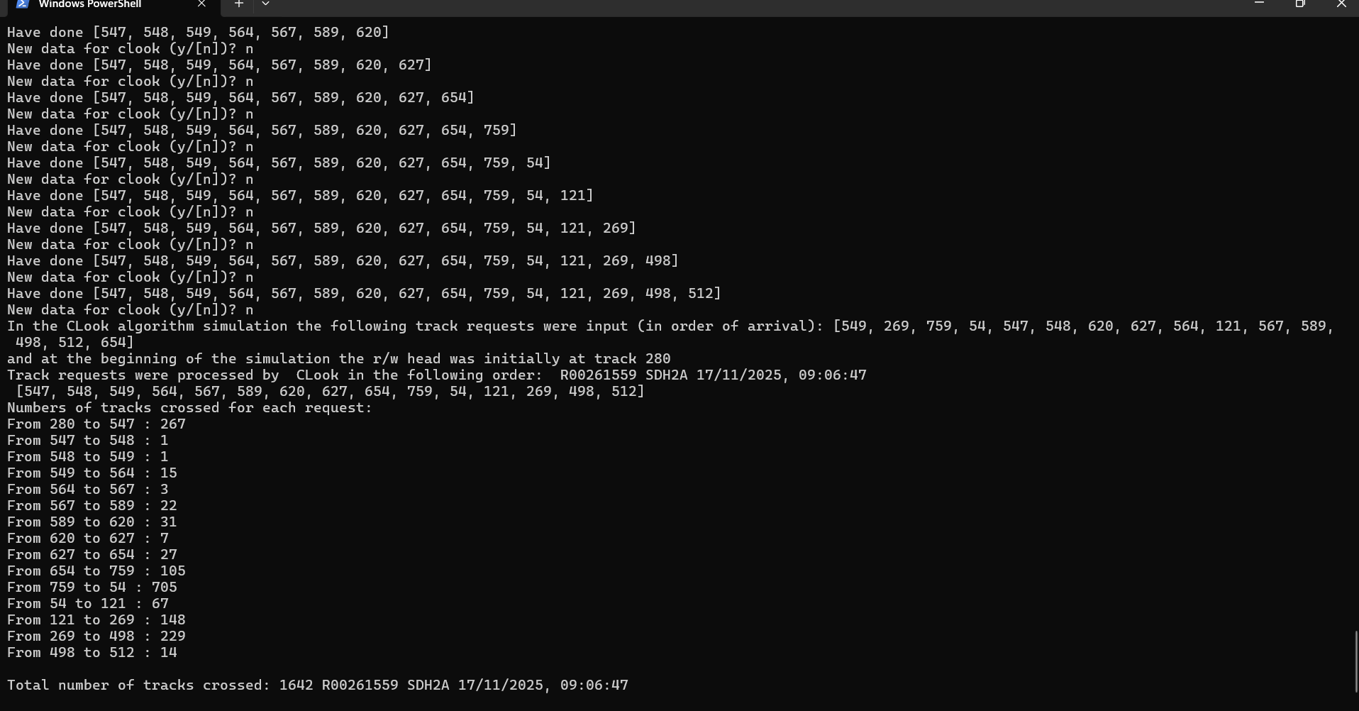

Fscan

************** fscan Algorithm **************

Choose Scan Direction

1: From 0 to 799
2: From 799 to 0
Which scanning direction (1 or 2)?1
Will you want to add data while tracks are being processed (y/[n])? y
Have done [547]
New data for fscan (y/[n])? n
Have done [547, 548]
New data for fscan (y/[n])? y
How many new Disk Track Requests (Max 10)? 5
Disk Track Requested (integer 0-799)? 234
Disk Track Requested (integer 0-799)? 564
Disk Track Requested (integer 0-799)? 524
Disk Track Requested (integer 0-799)? 467
Disk Track Requested (integer 0-799)? 389
Have done [547, 548, 549]
New data for fscan (y/[n])? n
Have done [547, 548, 549, 564]
New data for fscan (y/[n])? n
Have done [547, 548, 549, 564, 620]
New data for fscan (y/[n])? n
Have done [547, 548, 549, 564, 620, 627]
New data for fscan (y/[n])? n
Have done [547, 548, 549, 564, 620, 627, 759, 799]
New data for fscan (y/[n])? n
Have done [547, 548, 549, 564, 620, 627, 759, 799, 269]
New data for fscan (y/[n])? n
Have done [547, 548, 549, 564, 620, 627, 759, 799, 269, 121]
New data for fscan (y/[n])? n
Have done [547, 548, 549, 564, 620, 627, 759, 799, 269, 121, 54, 0]
New data for fscan (y/[n])? n
Have done [234]
New data for fscan (y/[n])? n
Have done [234, 389]
New data for fscan (y/[n])? n
Have done [234, 389, 467]
New data for fscan (y/[n])? n
Have done [234, 389, 467, 524]
New data for fscan (y/[n])? n
Have done [234, 389, 467, 524, 564, 799]
New data for fscan (y/[n])? n
In the FScan algorithm simulation the following track requests were input (in order of arrival): [549, 269, 759, 54, 547, 548, 620, 627, 564, 121, 234, 564, 524, 467, 389]
and at the beginning of the simulation the r/w head was initially at track 280
Track requests were processed by FScan in the following order: R00261559 SDH2A 17/11/2025, 09:06:47
[547, 548, 549, 564, 620, 627, 759, 799, 269, 121, 54, 0, 234, 389, 467, 524, 564, 799]
Numbers of tracks crossed for each request:
From 280 to 547 : 267
From 547 to 548 : 1
From 548 to 549 : 1
From 549 to 564 : 15
From 564 to 620 : 56
From 620 to 627 : 7
From 627 to 759 : 132
From 759 to 799 : 40
From 799 to 269 : 530
From 269 to 121 : 148
From 121 to 54 : 67
From 54 to 0 : 54
From 0 to 234 : 234
From 234 to 389 : 155
From 389 to 467 : 78
From 467 to 524 : 57
From 524 to 564 : 40
From 564 to 799 : 235

Total number of tracks crossed: 2117 R00261559 SDH2A 17/11/2025, 09:06:47

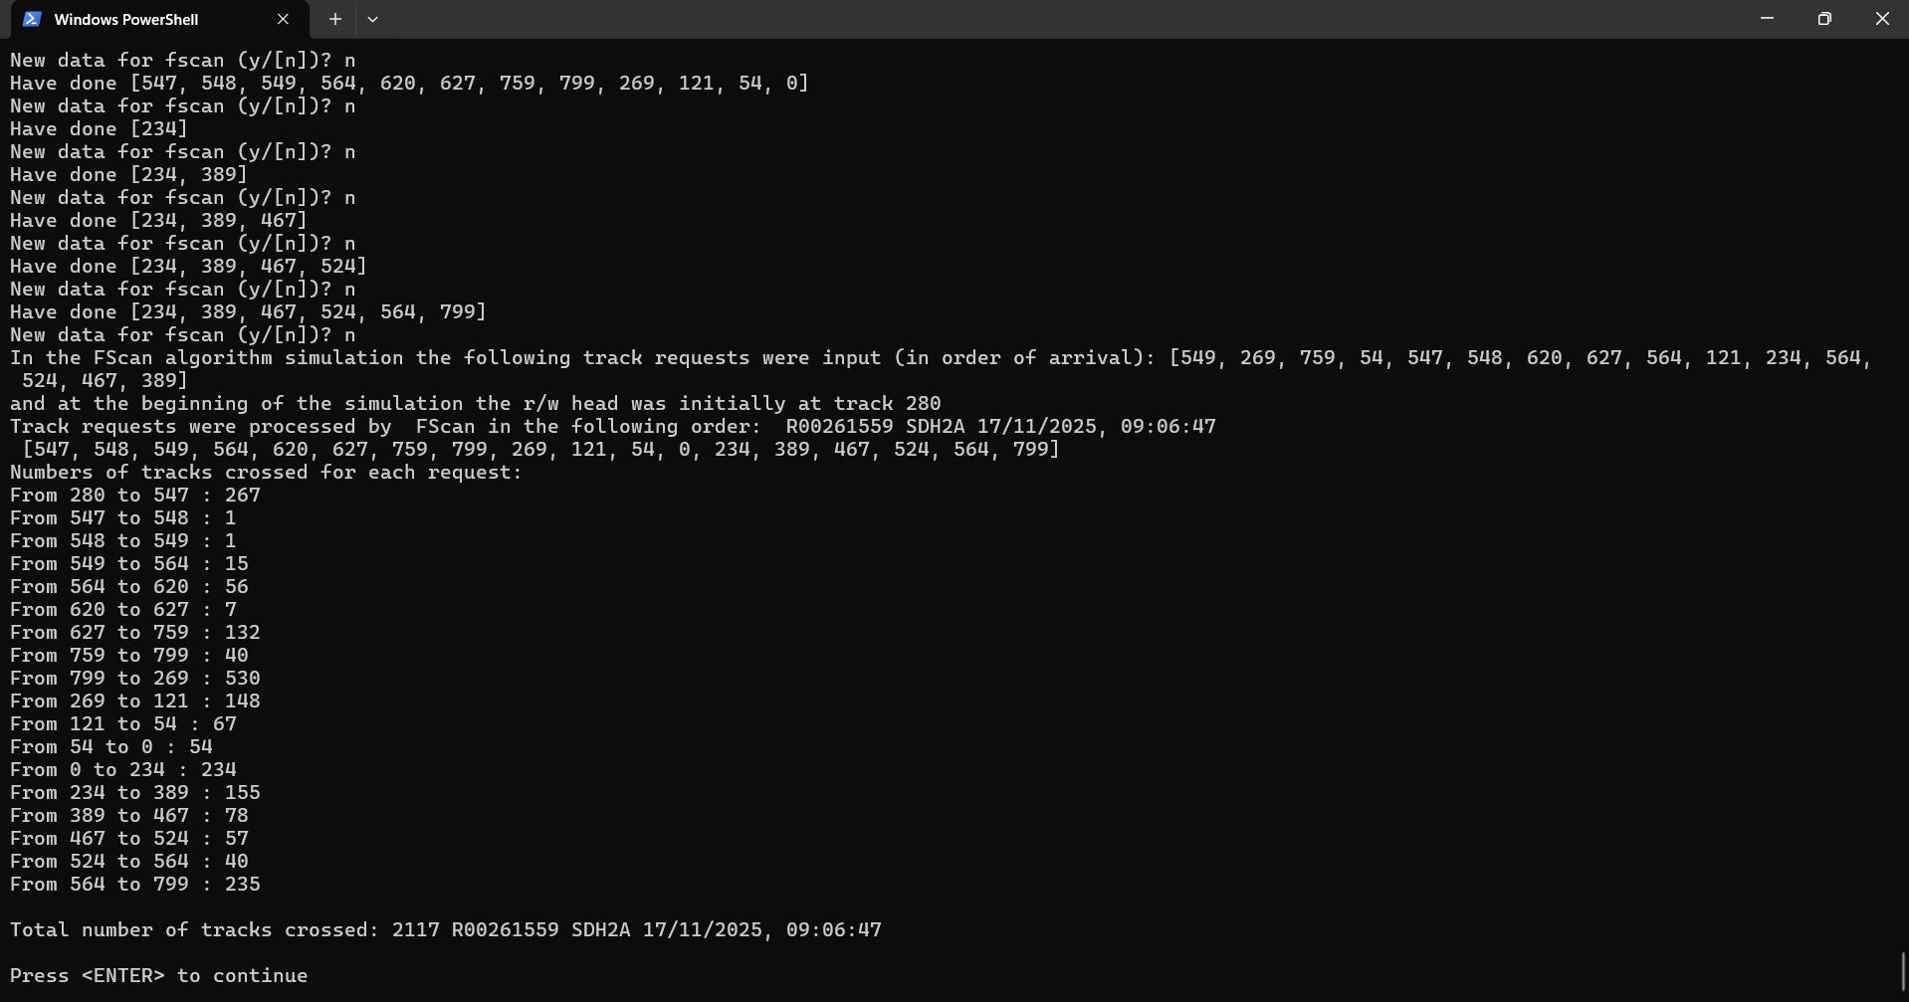

  - Using examples from the data fully explain why the algorithm made the choices it did in visiting each of the tracks in the order shown for:
    - Shortest Seek Time First (SSTF) (10 marks)
SSTF is a greedy algorithm that tries to minimize total seek time (how long it takes to look for the next track). It constantly looks at all the requests in the queue and chooses the request that requires the shortest number of tracks to cross. The processing order was “Track requests were processed by SSTF in the following order: R00261559 SDH2A 17/11/2025, 09:06:47 [269, 121, 54, 347, 491, 547, 548, 549, 564, 567, 582, 599, 620, 627, 759]”. The step of 547 → 548 → 549 shows this.

    - CLook (15 marks)
The CLook Scheduling Algorithm moves the disk arm (actuator arm that holds read/write heads, which is moved across different tracks) in one direction, and processes all the requests it meets along the way. It “looks ahead” into the direction it is going to see if there is any more requests. If yes, it continues in that direction. If no, it will immediately will “wrap around” (circular) to the location of the lowest pending request. In “Track requests were processed by CLook in the following order: R00261559 SDH2A 17/11/2025, 09:06:47 [547, 548, 549, 564, 567, 589, 620, 627, 654, 759, 54, 121, 269, 498, 512]”, you can see the “wrap around” when going from 759 → 54.

    - FScan (20 marks)
The Fscan Scheduling Algorithm moves the disk arm in one direction, and processes all requests it meets on the way. When it reaches the last track, it reverses and services requests it meets on the way back, like the Scan Scheduling Algorithm. However, the Fscan variant has a “freezing” feature to provide more consistent service times and to prevent starvation. Any new requests that arrive, once the sweep has started, are “frozen” into a separate queue. They will be processed once the current sweep is finished. The final processing order was “Track requests were processed by FScan in the following order: R00261559 SDH2A 17/11/2025, 09:06:47
[547, 548, 549, 564, 620, 627, 759, 799, 269, 121, 54, 0, 234, 389, 467, 524, 564, 799]”. I have added [234, 564, 524, 467, 389], which you can see at the end of the list, as they were added when the sweep had already started.

- (30 marks)
Comment on the fairness of how the added new requests were dealt with in each of your simulations:
    - Is there a danger of starvation? Explain why/why not using examples from your output. (10 marks)
    - Is there any unfairness? Explain why/why not using examples from your output. (10 marks)
    - Is there arm Stickiness? Explain why/why not using examples from your output. (10 marks)
SSTF
- Yes. SSTF always serves the request currently closest. Requests on the opposite end could be ignored completely.
ii. Yes. Requests closer to the current track get priority, while requests further away get terrible service.
iii. Yes and is a large reason of its starvation problem. If requests continue to arrive close to the arm head, then the further requests won’t be serviced.

C-Look
- No. C-Look services in one direction and then “wraps around” to ensure are missed/starved.
ii. Better than SSTF, but still unfair. The requests behind the head’s starting point have the longest wait.
iii. No. It is designed to be greedy in one direction. It will continue until the end of the request queue.

Fscan
- No. The algorithm uses two queues, making sure that all requests will be serviced.
ii. The fairest of the 3. All requests that had arrived before the sweep began get serviced, and the others must wait until it is finished.
iii. No. By freezing the incoming queue, the arm follows a single path to service all current requests.

Example run with FIFO – note that the requests added, highlighted in blue, are all near the current track. That is, in the example, the current track is 140 and the 5 requests added are nearby. You should use your own data and added tracks.
